**AIN SHAMS UNIVERSITY**

**FACULTY OF ENGINEERING**

**Manufacturing project**

|  |  |  |
| --- | --- | --- |
| NO. | Name | ID |
| 1 | Eslam Mahmoud Mohamed | 1902235 |
| 2 | Ahmed Khaled khalaf | 1700059 |
| 3 | Mohamed Hassan Ragab | 1807892 |
| 4 | Ahmed Abdel karim Ahmed | 1804221 |
| 5 | Ziad Mohammed Helmy | 1700567 |
| 6 | Abdelhamed Abubakrv Abdelhamed | 18t6373 |
| 7 | Ahmed Atef Talaat | 1807933 |

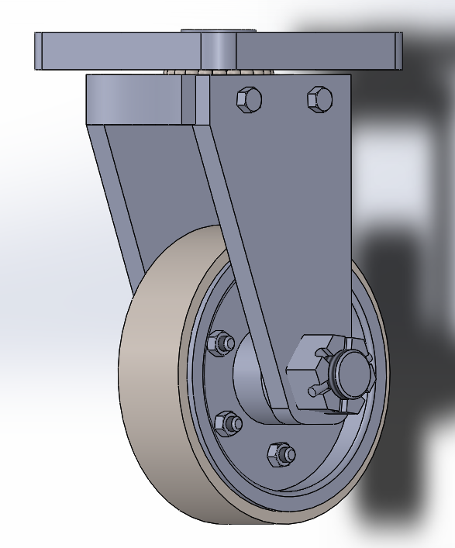

Heavy Duty caster

Part 1

Base

NO. OFF 1

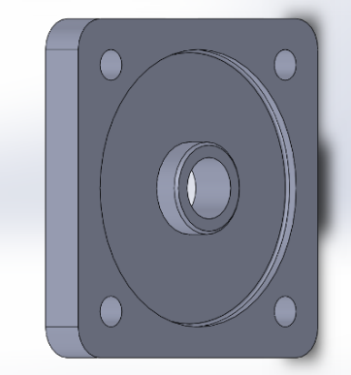

|  |  |
| --- | --- |
| Raw material | Before process |
| a=120 B=120 t=30 |  |

|  |  |
| --- | --- |
| **Manufacturing process** | After process |
| **a-vertical milling**  **1-face milling with depth of cut 5mm**  **2-end milling with depth of cut 5mm twice**  **3-mack chamfer**  **b-turning machine**  **1-facing with depth of cut 5mm and feed 40mm**  **2-facing to make D90 with depth of cut 4mm**  **c-drilling machine**  **1-drill D20**  **2-drill 4D10**  3-make counter sinking |  |

Part 2

Bush

No. off 1

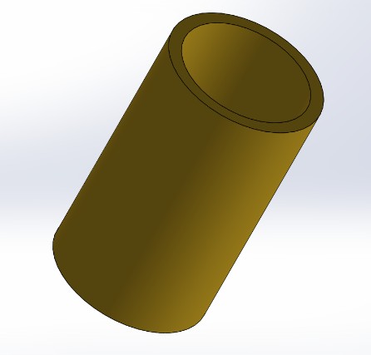

|  |  |
| --- | --- |
| Raw material | Before process |
| D=40  l=200 |  |

|  |  |
| --- | --- |
| **Manufacturing process** | After process |
| **1-Facing**  **2-use central drill to located the center of w.p**  **3-reduce the diameter to 35mm then to 30mm**  **4-parting off with leaving 5mm added to demanding length for the facing of the other face so parting off after 55mm**  **5-drill a through hole with a diameter 20mm then diameter 25mm**  **6-facing the other side** |  |

Part 3

Frame base

No. off 1

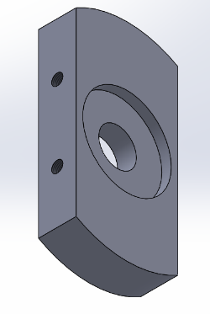

|  |  |
| --- | --- |
| Raw material | Before process |
| D=130  l=160 |  |

|  |  |
| --- | --- |
| **Manufacturing process** | After process |
| **1-Facing**  **2-use central drill to located the center of w.p**  **3-reduce the diameter to 105mm then to 100mm**  **4- parting off with leaving 5mm added to demanding length for the facing of the other face so parting off after 25mm**  **5- drill a through hole with a diameter 15mm then diameter 20mm**  **6-increase the inner diameter to 35mm and increase the depth to 5mm**  **7-repeat step(6) in the other side with change the inner diameter to 47mm**  **8-marking for shoot w.p from 2 sides**  **9-marking 4 centers for 4 holes**  **10-drilling 4 holes with depth 11mm and diameter 6mm**  **11- thread these holes(M6X1)** |  |

Part 4

Frame lift side

No. off 1

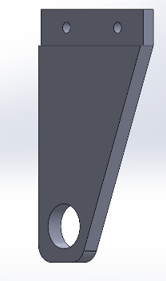

|  |  |
| --- | --- |
| Raw material | Before process |
| a=90 b=130 t=15 |  |

|  |  |
| --- | --- |
| **Manufacturing process** | After process |
| a- milling machine  1-horyzontal milling step 1-depth of cut 4mm  step 2-depth of cut 1mm  step 3-depth of cut 2mm  b-vertical milling machine  1-end milling with depth of cut 2.5  2-shering the slope  3-mack chamfer  c-drilling machine  1-center drill  2-drilling D6 through all  3-drilling D25 through all |  |

Part 5

Frame right side

No. off 1

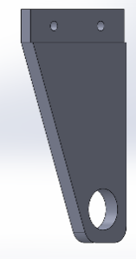

|  |  |
| --- | --- |
| Raw material | Before process |
| a=90 b=130 t=15 |  |

|  |  |
| --- | --- |
| **Manufacturing process** | After process |
| a-in milling machine  1-horyzontal milling step 1-depth of cut 4mm  step 2-depth of cut 1mm  step 3-depth of cut 2mm  b-vertical milling machine  1-shering edges  2-shering the slope  3-mack chamfer  c-drilling machine  1-center drill  2-drilling D6 through all  3-drilling D25 through all |  |

Part 9

King pin

No. off 1

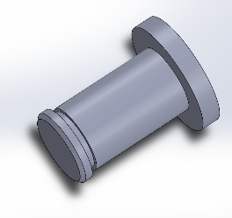

|  |  |
| --- | --- |
| Raw material | Before process |
| D=40  l=200 |  |

|  |  |
| --- | --- |
| **Manufacturing process** | After process |
| **1-Facing**  **2- use central drill to located the center of w.p**  **3- reduce the diameter to 35mm then to 30mm**  **4- reduce the diameter to 25mm then to 20mm with leaving 5mm in diameter 30mm in the side**  **5-leave 3mm from the other side then reduce the diameter to 18mm with depth 2mm**  **6-Making one chamfer by tilting the cutting tool 45**  **7- parting off with leaving 5mm added to demanding length for the facing of the other face so parting off after 43mm**  **8- Facing the other face** |  |

Part 11

Pin

No. off 1

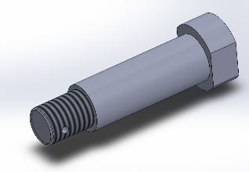

|  |  |
| --- | --- |
| Raw material | Before process |
| D=40  l=200 |  |

|  |  |
| --- | --- |
| **Manufacturing process** | After process |
| a-turning machine  1-straight turning D35 to length 107mm(depth of cut 5mm)  2- straight turning D25 to length 92mm (depth of cut 5mm twice)  3- straight turning D20 to length 25mm (depth of cut 5mm twice)  b-drilling machine  1-drill D4  c-vertical milling machine  1-sharing 2 chord in head of pin  d-turning machine  1-mack the thread |  |

Part 15

Tire

No. off 1

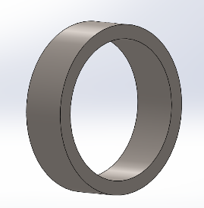

|  |  |
| --- | --- |
| Raw material | Before process |
| D=130  l=160 |  |

|  |  |
| --- | --- |
| **Manufacturing process** | After process |
| **a-turning machine**  **1-Facing**  **2- use central drill to located the center of W.P**  **3-** 2-turning with depth of cut 2.5mm to make D120 and feed 34mm. Repeat this 2 times  **4- parting off with leaving 5mm added to demanding length for the facing of the other face so parting off after 39mm**  **5-Drill through hole with any diameter**  **6-increase the inner diameter until reach to 100mm**  **7-Facing the other face** |  |

Part 16

Wheel flange

No. off 2

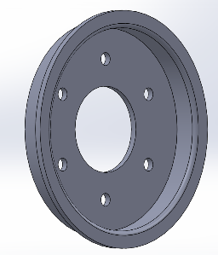

|  |  |
| --- | --- |
| Raw material | Before process |
| D=130  l=160 |  |

|  |  |
| --- | --- |
| **Manufacturing process** | After process |
| a-turning machine  1-facing  2-turning with depth of cut 2.5mm to make D110 and feed 16mm. Repeat this 4 times  3-cross turning to make D94 with depth of cut 3 and feed 47 from center. Repeat this 4 times  4-turning before 3mm with depth of cut 5mm and feed 12mm  5-cut W.P  b-drilling machine  1-centering all holes  2-drill D40  3-drill 6D6 |  |

Part 17

Wheel hub

No. off 1

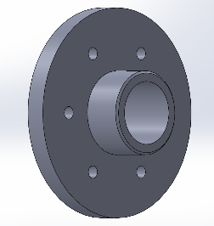

|  |  |
| --- | --- |
| Raw material | Before process |
| D=130  l=160 |  |

|  |  |
| --- | --- |
| **Manufacturing process** | After process |
| a-turning machine  1-facing  2-turning with depth of cut 2mm and feed 50. Repeat this 7times.  3- turning with depth of cut 1mm and feed 50. To make D100  4- turning with depth of cut 3mm and feed 20. Repeat this 10 times.  5-do the same in another direction.  6-make fillet  7-drill D30  8-Bore the hole  b-drilling machine  1-centering all holes  2-drill 6D6 |  |